NY-11
2016 IE Strategy Memorandum

Updated on 4/18/16
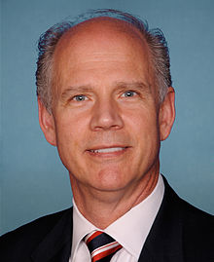


RICHARD REICHARD DANIEL DONOVAN
CoH: $ CoH: $368,389.42
Date: 4/15/16 Date: 4/15/16
Occupation: State Rep. Occupation: Congressman

SECTION I: Race Overview
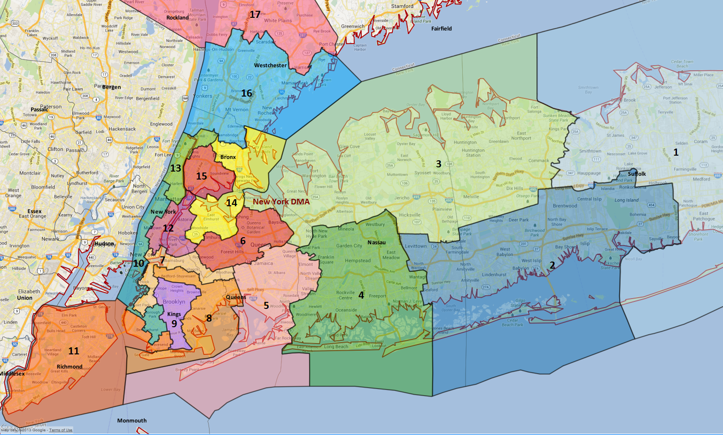

District/Media Market Map
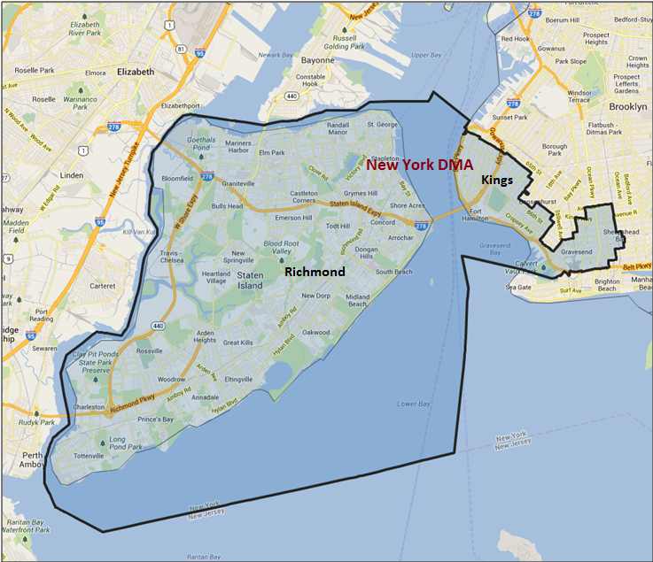

Media Market Costs

TV DMA | % of  CD | I.E.  35+ CPP | Cable CPP
NYC | 100% | $1975 | $550
NY-11 TOTALS: | 100%
Radio Landscape

NYC
Universe Size | CPP
265,500 | $850

Digital Landscape
  - Persuasion universe size: 29,792
  - Audience extension (key demos): Independents & Democrats
  - Weekly budget for full coverage: $8,170.61
  - Reach
    - YouTube - 347,828
    - Pandora - 185,853

Presidential Statistics
Cycle | Candidate | Party | Vote
2012 | Obama | DEM | 52.2%
2012 | Romney | REP | 47.8%
2008 | Obama | DEM | 49.38%
2008 | McCain | REP | 45.66%

Congressional Statistics
Cycle | W/L | Candidate | Party | Vote
2014 | L | RECCHIA | DEM | 43.45%
2014 | W | GRIMM | REP | 56.55%
2012 | L | MURPHY | DEM | 47.30%
2012 | W | GRIM | REP | 52.7%

NCEC Data
Dem Performance: 49.9%
BVAP: 6.7%
Hispanic: 12%
Asian: 10.6%
Total Minority: 29.3%

Critical Dates
Filing Date: April 1, 2016
Primary Date: June 28th 2016

Summary of 2014 Cycle Spending by Outside Groups to Date

TV Competitive Summary – New York City (Cable Only – State Island)
Campaign/Group | Total GRPs | Total Dollars
Domenic Recchia | 785 | $1,336,866
Michael Grimm | 565 | $635,966
DCCC | 2,999 | $1,305,343
House Majority PAC | 1,250 | $1,880,707
Good Guys vs Bad Guys | Total GRPs | Total Dollars
Good Guys | 5,034 | $4,522,916
Bad Guys | 565 | $635,966
TV Competitive Summary – New York City (Brooklyn – Addressable)
Campaign/Group | Total GRPs | Total Dollars
DCCC | 0 | $140,000
Good Guys vs Bad Guys | Total GRPs | Total Dollars
Good Guys | 0 | $140,000
Bad Guys | N/A | N/A

Summary of Digital Program: The 2014 DCCC IE invested in four rounds of persuasion digital advertising to match TV from Week 12 to Week 10, from Week 9 to Week 7, from Week 6 to Week 4 and from Week 3 to Week 1 in the New York City (Cable Only – Staten Island) Media Market.

Persuasion Program

The DCCC ran 4 rounds of digital advertisements matching the 4 TV ads we ran in the New York City (Cable Only – Staten Island) media market. The ads consisted of pre-roll video, Facebook, Twitter, and search ads, and banner ads.

The first round or digital corresponded with T03-Charges that ran from Week 12 to Week 10 (8/12 - 8/31). The second round of digital corresponded with T04-The Choice that ran from Week 9 to Week 7 (9/1 - 9/20). The third round of digital corresponded with T05-Moral that ran from Week 6 to Week 4 (9/21 – 10/11). The second round of digital corresponded with T06-Not The Guy that ran from Week 3 to Week 1 (10/12 – 11/4).

SECTION II: DISTRICT OVERVIEW

- District Overview and Data

  - Political Landscape
- In December 2014, incumbent Republican Michael Grimm pled guilty for felony tax evasion, and subsequently resigned. A May 5th 2015 special election resulted in the election of Republican Dan Donovan, a former district attorney for Staten Island and Republican nominee for attorney general in 2010. In that 2015 Congressional special election, Donovan defeated Vincent Gentile, a New York City Councilman from Brooklyn, earning 59.2% of the two-way vote, or 24,797 votes. Turnout was 10.3%, or 42,569 ballots cast.
- In a September 2015 DCCC IVR poll, Donovan’s favorability was at net +13 (34% fav / 21% unfav), with 45% unable to rate him. 44% of respondents said they would re-elect Donovan, and 50% said they would choose someone else. In the generic congressional ballot, voters chose a generic Republican over a generic Democrat by 12 points, 44% to 32%, with 24% undecided.
- Democrat Richard Reichard is a past president of the Staten Island Democratic Club and a retired city employee with the city Departments of Finance and Personnel. He won the Staten Island Democratic Party’s endorsement on March 3rd 2016.
- No Democratic candidates have yet declared, nor have any third party candidates.

  - District Demographics
- The district is comparatively diverse. By registration, 27% of voters are non-white, and 25% of people voting in 2012 were non-white. The district is 90.6% urban, and wealthier on average than the state or the country. Brooklyn and Staten Island’s North Shore are the most urbanized and diverse areas, while central and southern Staten Island are more relatively suburban and more predominantly White.

District Demographics

- Cook Partisan Voting Index: R+2
- Urban Population: 90.6%
- Rural Population: .9%
- Suburb Population: 8.4%
- Median Income: $67,756
- Poverty Status: 9.3%
- Military Veterans: 5.8%
- Race/Ethnic Origin: 70.7% White; 6.7% Black; 10.6% Asian; 12% Hispanic Origin

  - Electoral Context
  - While the Presidential nominees will not spend a great deal of money here, a former US Senator from New York at the top of the ballot has the potential to influence Democratic performance further down the ticket. In the September DCCC IVR in this district, Clinton’s favorability was at -34 (27 fav, 61 unfav). Down-ticket impacts of the various potential Republican nominees are not yet clear. The 2016 US Senate race features Chuck Schumer, who is unopposed as of yet, and has won this district handily in the past.
  - There are potentially five ballot measures that may appear on the general election ballot. They include a new referendum process, changing the age requirement to vote in primaries, a family court judge provision, and a plan to split Long Island’s Suffolk County into two counties. We do not currently expect any of these to drive turnout or swing support in this district, but we will continue to monitor their status.

  - Press Presence
- New York’s 11th Congressional District covers all of Staten Island, as well as part of southern Brooklyn, including the neighborhoods of Bay Ridge, Bensonhurst, Dyker Heights, and Gravesend. This district is entirely contained within the expensive New York media market, with a political CPP of $1,733 and an issue CPP of $2,079.

  - Campaign Team
N/A

- Donovan Top Hits

- Said he supported Kasich but would support Trump if he became the nominee.
- Voted to defund Planned Parenthood after saying he would oppose federal restrictions on abortions while he campaigned.
- Was district attorney in Eric Garner case, failed to secure grandy-jury indictment.
- Donovan is beholden to Washington Republicans: Donovan had to get his legislative plan approved by the NRCC in order to receive their political and financial support.
- Refuses to close dangerous loophole that allows suspected terrorists to purchase firearms and explosives.

